6A^{th} Grade: Unit 5, Lesson 1

- What is the relationship between the number of snakes compared to the total number of animals?
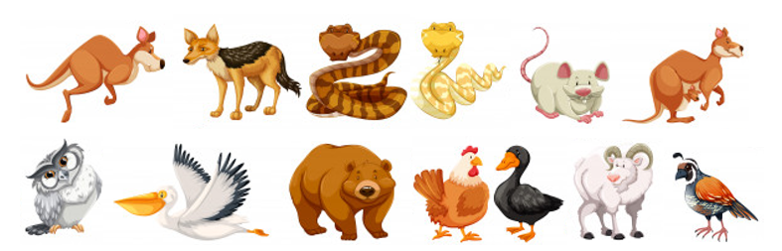

There are 2 snakes and there are 13 total animals.

- A recipe to make a carrot cake requires 3 eggs, 2 cups of flour, 4 cups of sugar, and 5 tablespoons of carrots. For every 3 eggs, how many cups of sugar will there be?

4

- Describe the numeric relationship between the two images.

There are 8 black stars and 12 white triangles.

